**APPLIED DATASCIENCE 1**

**ASSIGNMENT**

**Name: Shashank Reddy Bobbala**

**Student ID :** 22083114

**Module**: 7PAM2000-0901-2023 - Applied Data Science 1

**Course**: Msc Data Science (SW) with Placement Year

**GITHUB REPOSITORY LINK:**

<https://github.com/shashank02468/SHASHANK-B.git>

**DATA SOURCE LINKS:**

<https://www.kaggle.com/datasets/iamsouravbanerjee/world-population-dataset>

<https://www.kaggle.com/datasets/themrityunjaypathak/covid-cases-and-deaths-worldwide/>

**Visualisation 1:**

The total number of recovered cases relative to the total registered cases in various countries.

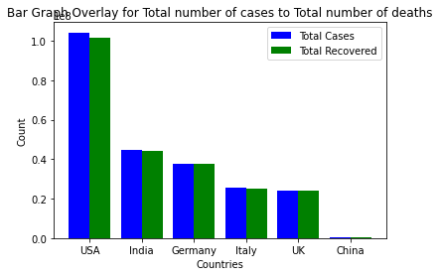

The bar graph above illustrates the ratio of registered COVID-19 cases to the recovered cases in different countries, with values presented in scientific notation (1e8, equivalent to 100 million) on the Y-axis. The United States has the highest number of registered COVID-19 cases, followed by India. However, when considering registered cases relative to the population, India shows a relatively moderate number of cases compared to other countries. The graph suggests that, overall, the recovery rate from COVID-19 is notably positive across all represented nations.

**Visualisation 2:**

“This visualization highlights the disparities between Germany and China in terms of three categories: Total Deaths, Active Cases, and Total Recovered.”

The pie charts above depict registered cases across various categories, including Total Deaths, Active Cases, and Total Recovered, for the countries Germany and China. This visual representation provides insights into the number of people who have recovered, the count of active cases, and the incidence of deaths among registered cases in these two countries. According to the charts, approximately 95% of registered COVID-19 cases have resulted in recoveries, with a very low number of deaths and less than 1% of cases still active. In contrast, while China has a higher recovery rate of over 75%, there are a notable number of active cases. Fortunately, the number of registered deaths remains low. The legend above displays the total registered cases, with the pie charts illustrating the distribution among the mentioned categories.

**Visualisation 3**

The graph provides a visual representation of how the population has evolved over the years in different countries.

The graph vividly illustrates the remarkable population growth between 1990 and 2020 across various countries, including India, the United States, the United Kingdom, and China. Notably, China has consistently maintained the highest population count during this period, while India experienced a rapid surge in population post-2018, approaching levels similar to China by 2020. Conversely, the United Kingdom has exhibited a relatively modest and consistent population growth rate, while the United States saw a slight uptick in growth between 2015 and 2020, subsequently stabilizing.